Prompting Charitable Donations from Winning Customers

**Emerging Brief**

What do we need now:

* Visualisation of the user experience - like a flow diagram
* Some mocked up UX images for key user decision points
* A pitch deck using the above images to build more tangibility into my pitch (in progress)

Below I set out a bit more about the UX experience, some suggested pages to design.

From these images I need to build a pitch deck that contains broadly the same sections as are in the 2 pager I sent you summarising this pitch. So

* Overview / mission
* Background including
  + Trust in the gambling industry
  + Charity donation acceptance from industry
  + Enhancing the win
* Available £
* Stakeholder benefits
* Risks and challenges
* Next steps

**Mission statement**: Building charitable donations into gambling transactions.

**Name Ideas**: “charitify”, “loterrify”, “tipping” “tippify” (Mykro.giving, Mykro.donate)

### **1. User Flow Diagram to articulate the customer journey**

A diagram mapping out the journey a user would take when interacting with the donation feature. This should include:

* **Entry Points** (e.g., after a win, within account settings, via a pop-up prompt, on sign up).
* **Decision Points** (e.g., choosing donation amounts/percentages, frequency, selecting cause, confirming the donation).
* **Feedback Mechanisms** (e.g., confirmation screens, tracking past donations, feedback to customer on impact of donations, ).

### **2. Wireframes / UI Mockups to show the key decision points visually**

Visual representations of the key screens users will interact with. Possible screens include:

* **Win Notification with Donation Prompt** – A modal/pop-up when a user wins, asking if they’d like to donate a portion.
* **Donation Selection Screen** – Options for how much to donate (fixed %, slider, manual input).
* **Charity Selection Screen** – If applicable, a list of approved charities to choose from.
* **Confirmation Screen** – Displays a summary before the user confirms.
* **Tracking & History** – A dashboard showing past donations and potential impact.

Here are example key screens for designing wireframes:

### **Key Screens for the Donation Feature**

1. **Win Notification with Donation Prompt**
   * Appears when a user wins a bet.
   * Asks if they want to donate a portion of their winnings.
   * Options: "Donate Now," "Set Up Auto-Donations," or "No Thanks."
2. **Donation Selection Screen**
   * If the user chooses "Donate Now," they can select an amount.
   * Options: Fixed % (e.g., 1%, 2% 5%), custom amount, or a slider.
3. **Charity Selection Screen (if applicable)**
   * List of charities the user can donate to.
   * Or “types of charities” - e.g. “animal welfare / young people / mental health / cancer / environmental”
   * I like the idea of gamification elements here, too - e.g.a roulette wheel of organisations (if you dont feel strongly who you want to donate to)
   * Options: Choose a charity, auto-distribute among charities, or default selection.
   * Options: “charity of the month” where your donation will be matched by the gambling operator
4. **Confirmation Screen**
   * Shows donation amount, chosen charity, and payment method.
   * "Confirm Donation" button.
5. **Donation Success / Thank You Screen**
   * Confirms donation was successful.
   * Displays impact summary (e.g., "Your donation helps provide X").
   * Option to share the donation or return to gambling.
6. **Donation History & Tracking (within Account Settings)**
   * Lists past donations and total amount donated.
   * May include a leaderboard or badges for frequent donors (again gamification elements here might be nice)
   * Option to adjust future donation settings.
7. **Settings Page**
   * Enables users to opt in/out of donations.
   * Adjust recurring donation rules (e.g., auto-donate X% of each win).
   * Set a monthly donation cap.

Here is the example from chatgpt. It is ugly but it gives you a sense of what I think I need.

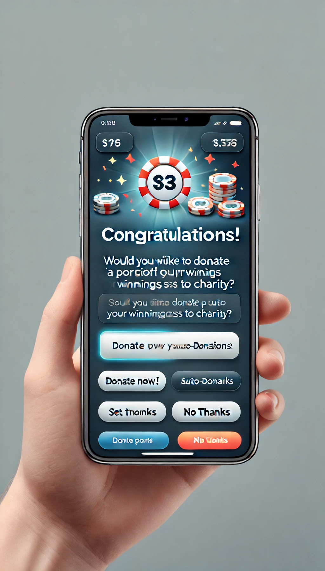

Something more bare-bonesy, non-corporate and charitable would be a lot better. I have given some examples of warmer, more colourful imagery below

Here is a chatgpt example of something more with a more genric charity vibe.

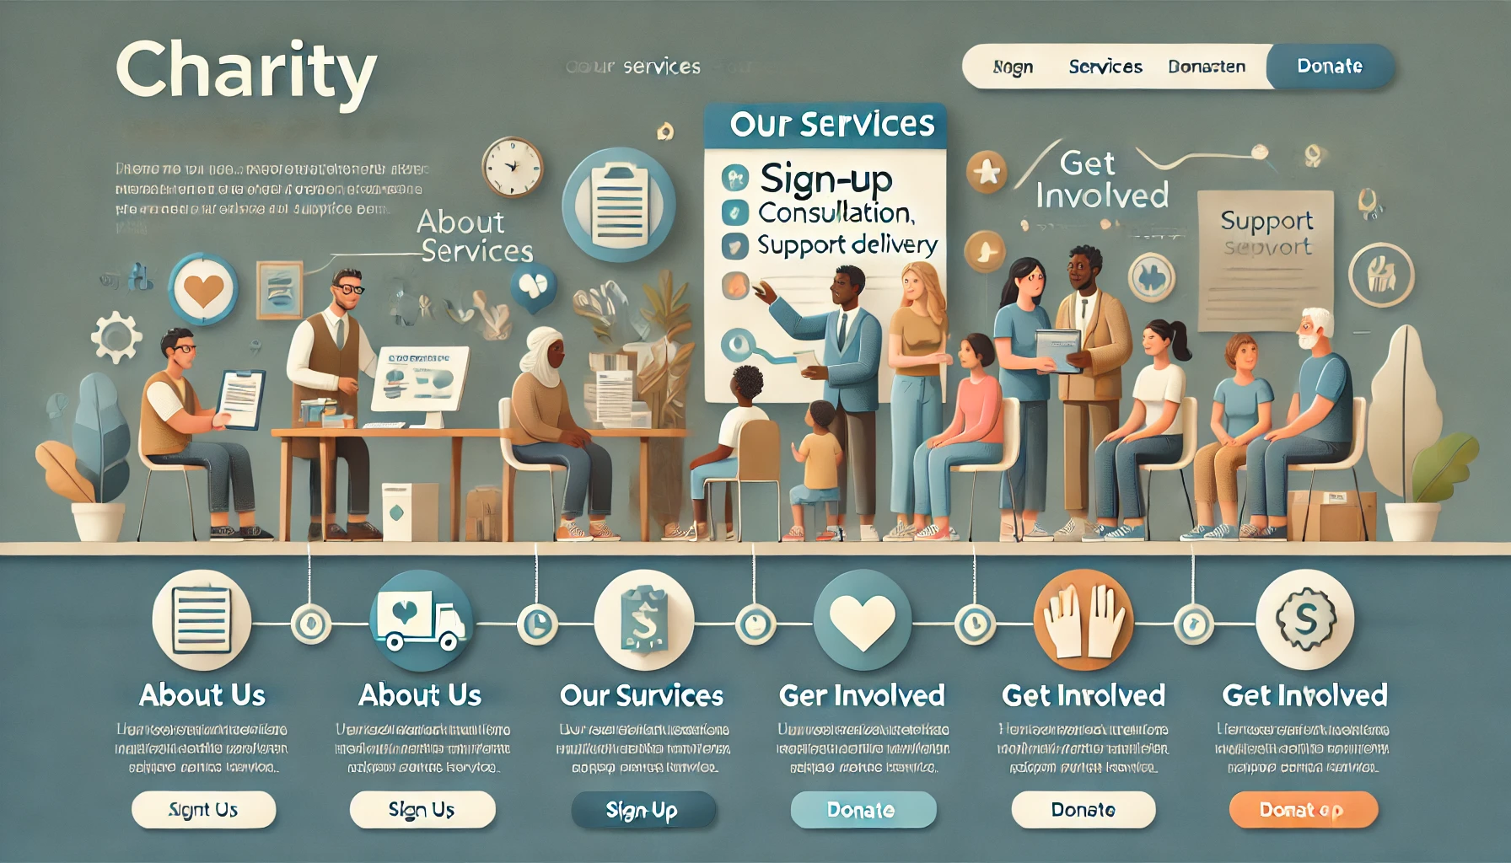

or

or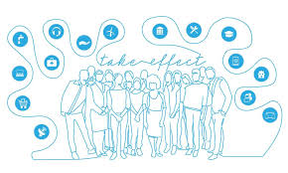

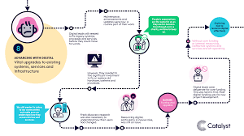

Not sure if that makes sense but in essence I want this product to look and feel warm and charity oriented in contrast to the ugly fast paced, sporty images of gambling apps.